WEBSITE COMMENT

1. I cant find the super admin access. There is no super admin section on the website created. Incase Victor does not understand what a Super-Admin is, I will suggest he discuss with Chibuokem Ibezim so they can sort this out.
2. On the Profile Section of the Admin Dashboard, there should be an arrow that indicates that users can click on the drop-down arrow to find the options of all banks.

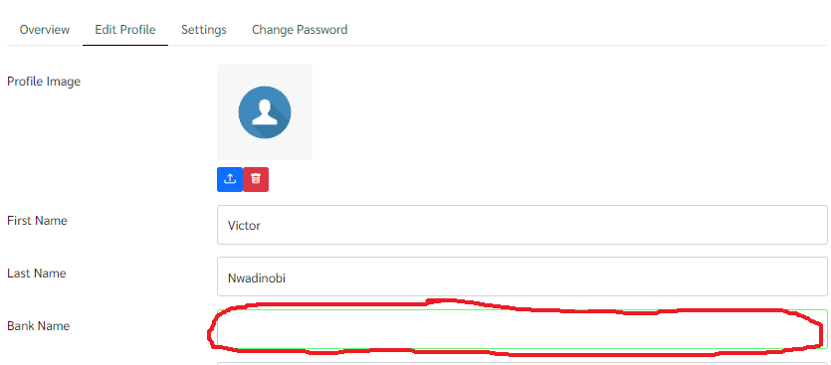

1. On the dashboard option, when a user clicks on any dashboard menu option, there should be a background that is fixed so that the user can know the option they clicked even after they remove the mouse from there:

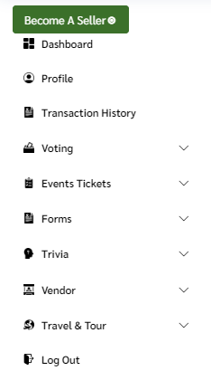

1. When users are switching from their buyers profile to their sellers profile, to fill any part of the form should not be compulsory. You made it important here that users must provide their Facebook, Instagram and Twitter age. And without these, the users wont switch. Note that the form filed on all the website, nothing should be compulsory to fill:

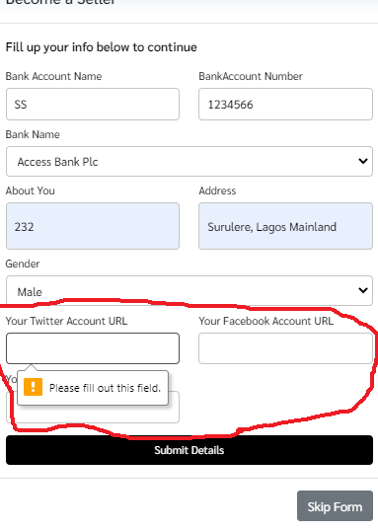

**NOTE: YOU DIDN’T DO A GOOD JOB ON THE USER ADMIN PAGE. WHEN USERS LAND ON THAT PAGE, THEY WILL GET SO CONFUSED AS THEY ARE NOT SURE IF THAT IS WHERE THEY ARE TO BEGIN LISTING THEIR SERVICES.**

SINCE THE SAME PROFILE THAT IS ON THE USER ADMIN IS STILL ON THE SELLERS ADMIN, INSTEAD OF THE REPETITION, LETS REMOVE THE USER-ADMIN. BECAUSE THE UI/UX DID A TERRIBLE JOB AND WE ARE TIRED OF EXPLAINING.

ON THE SWITCHING EXPERIENCE. I SWITCHED TO A SELLER AND I HAD TO MANUALLY REFRESH MY PAGE FOR THE SYSTEM TO BECOME UPDATED. PLEASE MAKE THIS AUTOMATED.

…………………………………………..

SELLER ADMIN

1. Voting Seller-Admin Menu – On the voting sub-menu a lot of items are missing. See below:

GREENMOUSE VOTING ADMIN

EXISTING WEBSITE VOTING ADMIN

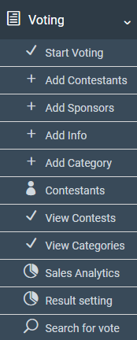

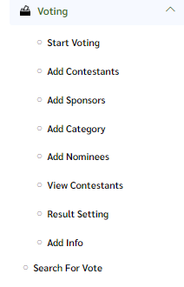

**The missing pages include: Contestants, View Contests, View Categories, Sales Analytics. Please liaise with Chibuokem Ibezim to understand better.**

1. Registration Seller-Admin Menu – On the registration sub-menu a lot of items are missing. See below:

EXISTING WEBSITE REGISTRATION ADMIN

GREENMOUSE REGISTRATION ADMIN

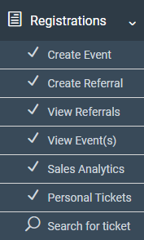

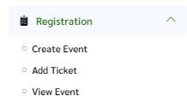

**The missing pages include: Create Referral, View Referrals, Sales Analytics, Personal Tickets, Search for Tickets.**

1. Form Seller-Admin Menu – On the form sub-menu a lot of items are missing. See below:

GREENMOUSE FORM ADMIN

EXISTING WEBSITE FORM ADMIN

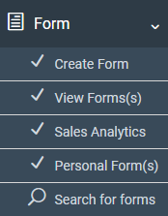

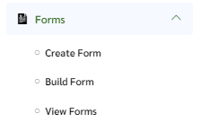

**The missing pages include: Sales Analytics, Personal Forms, Search for Forms.**

1. Trivia Seller-Admin Menu – On the trivia sub-menu a lot of items are missing. See below:

GREENMOUSE FORM ADMIN

EXISTING WEBSITE FORM ADMIN

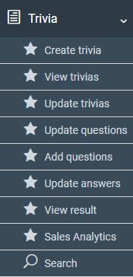

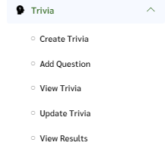

**The missing pages include: Update questions, update answers, sales analytics, search.**

1. Vendor Seller-Admin Menu – On the vendor sub-menu a lot of items are missing. See below:

GREENMOUSE FORM ADMIN

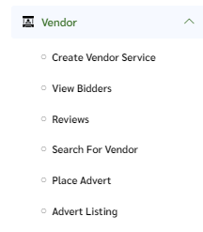

**The missing pages include: View all Enquiries, View All Vendor Services, View all Bided Projects, View All Advert Performance, Edit Vendor Services, Delete Vendor Services, Sales Analytics.**

1. Travel & Tours Seller-Admin Menu – On the travel & tours sub-menu a lot of items are missing. See below:

GREENMOUSE FORM ADMIN

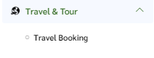

**The missing pages include: Hotel, Tours, IELTS, Sales Analysis**